**Name: Muhammad Shafey**

**Intern ID: TN/IN02/PY/023**

**Email ID: muhammadshafey248@gmail.com**

**Task Week: 02**

**Internship Domain: Python Development**

**Instructor Name: Mr.Hassan Ali**

**Tasks: Data Structure & Functions**

**Task no:01**

* **Lists:**

**Question:**

Store 5 student names & print each?

**Answer:**

**Code Snippett:**

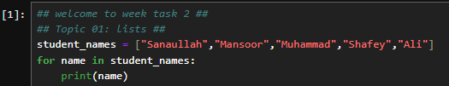

**Output Snippett:**

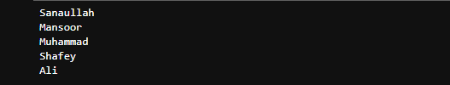

**Question:**

Reverse list without reverse()?

**Answer:**

**Code Snippett:**

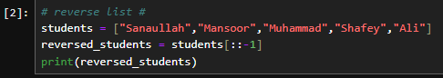

**Output Snippett:**



**Task no:02**

* **Tuples:**

**Question:**

Store 3 coordinates & unpack?

**Answer:**

**Code Snippett:**

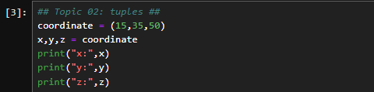

**Output Snippett:**

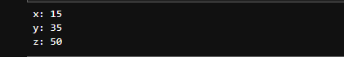

**Question:**

Swap vars using tuple assignment?

**Answer:**

**Code Snippett:**

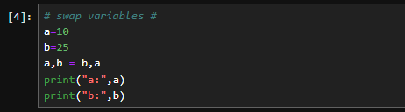

**Output Snippett:**



**Task no:03**

* **Sets:**

**Question:**

Remove duplicates from list?

**Answer:**

**Code Snippett:**

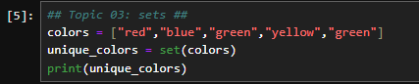

**Output Snippett:**



**Question:**

Find intersection of two sets?

**Answer:**

**Code Snippett:**

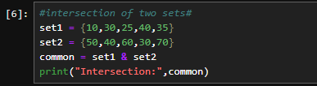

**Output Snippett:**



**Task no:04**

* **Dictionaries:**

**Question:**

Student record CRUD in dict?

**Answer:**

**Code Snippett:**

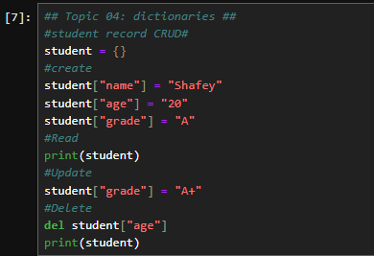

**Output Snippett:**



**Question:**

Count word frequency in sentence?

**Answer:**

**Code Snippett:**

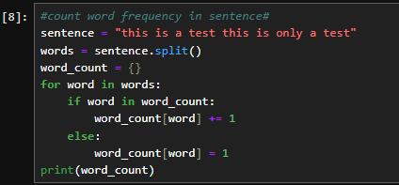

**Output Snippett:**



**Task no:05**

* **Functions:**

**Question:**

Write calc(a,b,op)?

**Answer:**

**Code Snippett:**

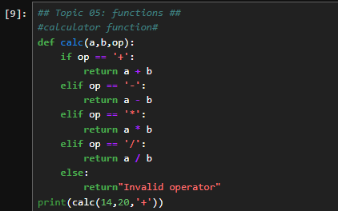

**Output Snippett:**



**Question:**

Write factorial(n) recursive?

**Answer:**

**Code Snippett:**

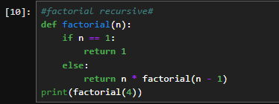

**Output Snippett:**



**Task no:06**

* **Modules:**

**Question:**

Use random & datetime in script?

**Answer:**

**Code Snippett:**

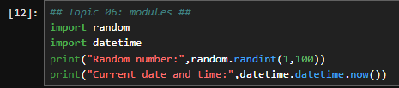

**Output Snippett:**



**Question:**

Create math_utils module & import?

**Answer:**

**Code Snippett:**



**Output Snippett:**



**Task no:07**

* **Exceptions:**

**Question:**

Safe int input loop?

**Answer:**

**Code Snippett:**

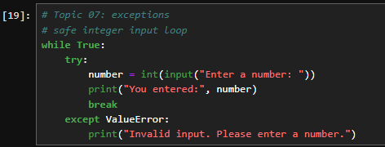

**Output Snippett:**



**Question:**

File open with error message?

**Answer:**

**Code Snippett:**

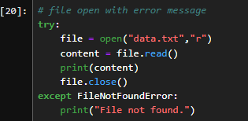

**Output Snippett:**



**Task no:08**

**Question:**

Phonebook App: CRUD contacts dict <-> JSON file storage?

**Answer:**

**Code Snippett:**

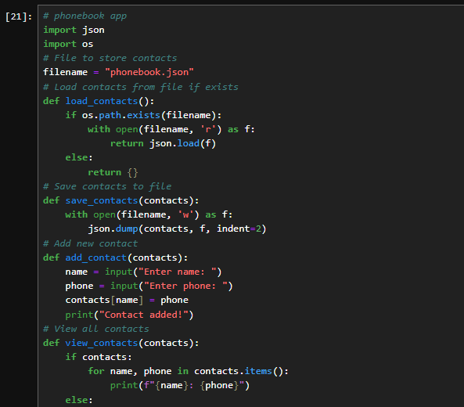

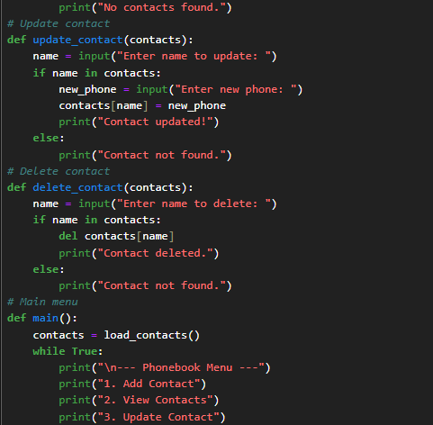

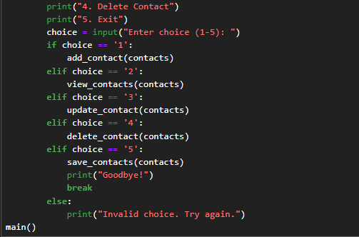

**Output Snippett:**

